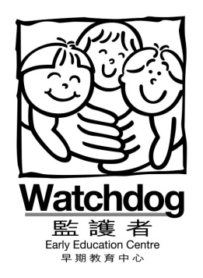 | To | : | All Parents
 | From | : | Stella Wong, Executive Director
 | Re | : | Declaration of your child’s school with URTI outbreak
 | Date | : | 6th May, 2021
 | Circular No | : | WDM005/2021

Dear Parents,

As you are aware, Center for Health Protection (CHP) is paying close attention to COVID-19 cases involving N501Y mutant strain as this variant has been shown to be more infectious than its parent strain. On top of that, currently there are outbreaks of URTI in some kindergartens. Since the symptoms of Upper Respiratory Trace Infection (URTI) are similar to those of Covid-19, the government has required everyone in schools/KGs with the outbreaks to undergo the compulsory testing to exclude the possibility of Covid-19 infection.

In light of the government measure to prevent the spread of the virus and to ensure the safety of our students and staffs at our centre, we would like to remind parents/carers to notify us if the kindergarten/school your child is attending is:
- having URTI outbreak
- the school is suspended due to URTI outbreak and requires all children to take the COVID-19 test

If the kindergarten your child is attending requires your child to take the COVID-19 test, please let us know and resume the center sessions AFTER the negative test result comes out. (Please send us the test result prior to resuming the sessions).

Besides, as a gentle reminder, if your child is feeling sick and/or having symptoms of Upper Respiratory Tract Infections, please keep him/her at home and consult a doctor immediately.

We appreciate your cooperation in this matter to ensure you, your children and everyone at Watchdog keeping well and healthy.

Should you have any questions, please do not hesitate to call Ms Pinky, our Administrative Secretary (Hong Kong Centre) at 2521-7364 (Hong Kong Centre) or Ms Abby, our Administrative Secretary (Jordan Centre at 2377-9666.

Best regards,
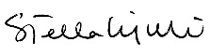

Stella Wong
Executive Director

